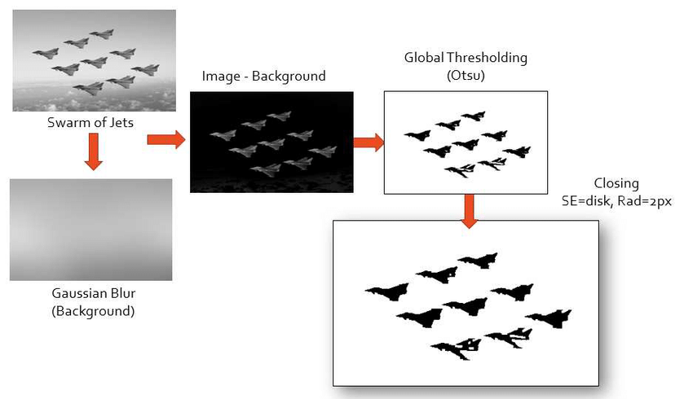

Image Segmentation Block Diagram by Gazi Sultan

Image Processing Workflow Diagram

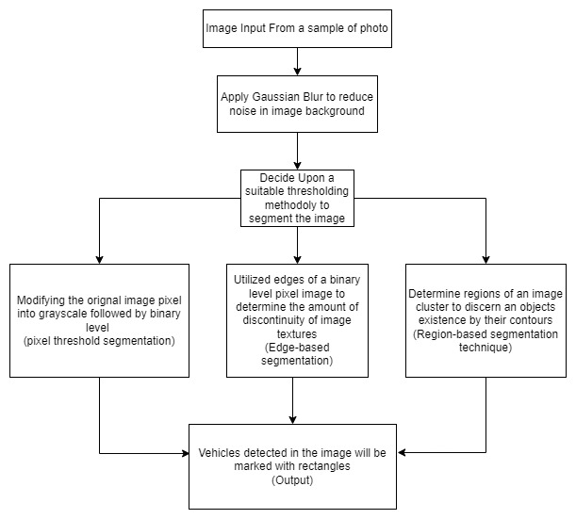

Image Processing Outcome Diagram

